Decision Tree Golf Dataset encoding

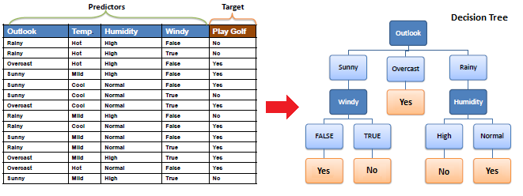

Outlook:

* Rainy = 0
* Overcast = 1
* Sunny = 2

Temp:

* Cool = 0
* Mild = 1
* Hot = 2

Humidity:

* Normal = 0
* High = 1

Windy:

* False = 0
* True = 1

Play Golf:

* No = 0
* Yes = 1